Title: Maximum shoulder press strength relative to body mass as a good predictor of strict handstand push-up performance in CrossFit® practitioners

ABSTRACT
Purpose
The purpose of this study was to investigate the relationship between relative maximal shoulder press (SP) strength and maximum repetitions in the strict handstand push-up (SHSPU) in CrossFit® practitioners.
Methods
One hundred and eight adults (57 males, 51 females; 30.2 ± 7.4 years) with at least three months of CrossFit® experience participated in this study. Participants performed a maximum repetition SHSPU test and a one-repetition maximum shoulder press (1RM SP) test. Relative strength was calculated as 1RM divided by body mass (%SP). Linear regression models analyzed the associations between %SP, training experience, and SHSPU repetitions.
Results
Relative strength in the SP was a significant predictor of SHSPU performance (R²=0.646, p<0.001), explaining 64.6% of the variance. The regression model (y=−15.2+0.314x) indicated a minimum threshold of approximately 51.8% of body mass in the SP to perform a single SHSPU repetition. Furthermore, every 3.2% increase in relative SP strength was associated with one additional SHSPU repetition. CrossFit® training experience was not a significant predictor of SHSPU performance (p=0.307).
Conclusion
Relative overhead pressing strength is a fundamental prerequisite for SHSPU mastery. Strength and conditioning coaches can utilize the 51.8% SP threshold as an objective benchmark to assess athlete readiness and safety before progressing to inversion-based gymnastics skills.
Keywords: functional fitness, gymnastics, upper-body strength, performance prediction, resistance training.

INTRODUCTION
CrossFit® is one of the most well-known high-intensity functional training methodologies worldwide. According to the CrossFit® Level 1 Training Guide [8], it aims to develop a broad, general, and inclusive fitness model by enhancing ten physical capacities: cardiorespiratory endurance, muscular endurance, flexibility, strength, power, speed, coordination, agility, balance, and accuracy. This is achieved through a combination of methodologies and sports disciplines, with training sessions termed as the "Workout of the Day" (WOD) incorporating running, jump rope, cycling, rowing, gymnastics movements, and Olympic weightlifting.
One foundational exercise targeting maximal strength development in CrossFit® is the shoulder press (SP), involving the scapular girdle, arms, forearms, and wrists. The CrossFit® Level 1 Training Guide [3] classifies the SP as essential for all overhead lifting exercises, commonly performed with a straight metal barbell and weight plates. Therefore, the SP allows a measurable increase in intensity by progressively adding external load lifted overhead by the upper limbs [19]. In contrast, gymnastics-based skills, such as the strict handstand push-up (SHSPU), rely on an athlete's body weight as resistance, with progression depending on the ratio between strength and body mass [8]. Although it follows a similar pressing pattern to the SP, it is inverted in nature. The movement begins with the athlete in a headstand position, where the hands are placed slightly wider than shoulder-width for stability, forming a tripod base, with the feet touching a wall. From this position, the exercise involves elevating the body into a fully extended handstand, overcoming gravity while maintaining an inverted position, without using any additional momentum [4]. This presents a unique challenge in strength training periodization, as progression relies on neuromuscular adaptation rather than incremental external loads.
Mastering the SHSPU demands not only significant upper body strength but also enhanced spatial awareness due to vestibular, visual, and somatosensory system adaptations in an inverted posture, alongside psychological readiness to mitigate fear of falling [11]. The CrossFit® official guide prescribes six progressions for SHSPU [4]. Five are bodyweight-based and require independent skill acquisition, while the only externally loaded progression involves SP, but without any precise guideline for progression. This highlights the potential difficulties in SHSPU mastery and the necessity for coaches to employ adjustments tailored to individual needs. A study with 1,325 CrossFit® athletes, 75% of whom had at least one year of experience, revealed that 39.5% were unable to perform a single SHSPU repetition. Additionally, safety concerns arise because insufficient strength assessments and improper conditioning may increase injury risk, particularly in the shoulders and lumbar region, common injury sites in gymnastics and Olympic weightlifting movements within CrossFit® [20, 22].
A key consideration in SHSPU execution within CrossFit® is the use of head support during movement transitions, shifting between a three-point base (head and hands) and a two-point handstand position through elbow extension and shoulder abduction. This results in potential cervical spine compression forces. Limited research has quantified head-support forces in such contexts, but studies on yoga’s Sirsasana (headstand) suggest a load equivalent to 40–48% of body weight when maintaining stability [9]. Given CrossFit®'s high-volume, high-intensity training nature, cumulative fatigue may exacerbate force transmission to the cervical spine, raising safety concerns even for proficient athletes. With over 5 million practitioners and 13,000 affiliated locations in 155 countries [2], improved training protocols and specific requirements for SHSPU could significantly enhance performance and safety within CrossFit® and similar high-intensity functional programs [6].
While SP and SHSPU share fundamental movement patterns and require significant upper limb strength, key biomechanical differences exist. In SP, the hands begin slightly above shoulder height, while in SHSPU, they align with the top of the head. This might affect the force-length relationship of the muscles involved, as extreme elongation or shortening of muscle fibers can reduce active force output due to suboptimal sarcomere overlap [16]. In SP, the triceps brachii, particularly the long head, is positioned in a more lengthened state because of simultaneous shoulder and elbow flexion, potentially placing it beyond the optimal range for maximal force production. In contrast, during SHSPU, the elbows are typically flexed near 90 degrees, and the shoulders are in a greater flexion degree than in SP, with elevated scapulae, resulting in a potentially more favorable length-tension configuration. This elbow positioning has been associated with higher activation and force output across all heads of the triceps, particularly the medial head [12]. Additionally, SHSPU is performed in a closed kinetic chain, which provides greater joint stability and allows primary movers to operate more efficiently under load, compared to the open kinetic chain mechanics of SP that impose greater demands on stabilization [17]. These combined factors may help explain why individuals are able to complete SHSPU despite having a 1RM in the shoulder press below their body mass.
Despite the biomechanical differences between SP and SHSPU, evidence from studies comparing exercises with different stability and kinetic chain demands suggests that neuromuscular adaptations could transfer between these exercises [21]. Similar levels of muscle activation and strength development have been observed between free-weight, machine-based, and bodyweight pressing exercises, despite their mechanical differences [10, 17, 21]. Consequently, it seems reasonable to expect that SP maximal strength is associated with SHSPU performance.
This study aimed to investigate the relationship between SP and SHSPU in the context of strength training and skill acquisition. It was hypothesized that maximal strength in the SP would be positively and significantly correlated with SHSPU performance. Understanding the degree of carryover between these exercises could inform training strategies, optimizing strength progression and movement efficiency.
METHODS

Experimental Approach to the Problem
This study employed a cross-sectional design to investigate whether relative maximal strength in the SP predicts SHSPU performance in physically active adults engaged in CrossFit®. To this end, we measured relative maximal SP strength and the maximum number of SHSPU repetitions and performed a linear regression analysis.

Subjects
A total of 108 adults (66 males, 42 females), aged 18–50 years, were recruited for this study. Participants were required to have at least three months of consistent CrossFit® training. All participants provided written informed consent before participation, the study adhered to the principles stated in the Declaration of Helsinki, and was approved by the Research Ethics Committee of the School of Physical Education and Sports of Ribeirão Preto. Exclusion criteria were: inability to attend testing sessions at the scheduled times, musculoskeletal injury in the upper limbs within the past 12 months, and any medical condition contraindicating participation in the physical assessments.

Procedures
Testing was conducted at a CrossFit® facility (Ribeirão Preto, Brazil). To ensure consistency, all assessments were performed on the same day [Figure 1].
Fig, 1 Experimental design flowchart
Testing procedures were standardized, with all participants receiving identical instructions and utilizing the same equipment. The same warm-up protocol was implemented prior to testing, consisting of 10 minutes of dynamic joint mobility exercises targeting the upper extremity, followed by three sets of specific activation exercises for the shoulder complex and core: 5 inverted bodyweight presses (hips flexed at 90°), 10 prone scapular snow angels, and a 20-second isometric prone bridge with full elbow extension. Immediately following the warm-up, the participants first performed a maximum repetition test for the SHSPU, followed by a 1-repetition maximum (1RM) SP test, with a 5-minute rest interval between protocols.
Hand placement for both exercises was restricted to a maximum width of 81 cm, delimited by adhesive tape [Figure 2 ]. This limit was established based on standard barbell markings to ensure consistent range of motion and prevent excessively wide grips during the SHSPU. Within this constraint, participants were permitted to adopt their habitual hand positioning.
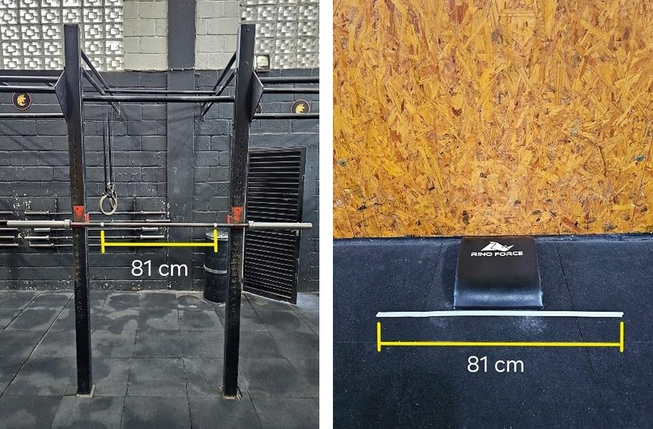
Fig. 2 Delineation of the maximum hand placement width for the SP and SHSPU tests, respectively

Strict Handstand Push-Up Test
The SHSPU test began with participants assuming a headstand position, with hands placed on the floor, head supported on a padded mat (AbMat, Rino Force, São Carlos, Brazil), and feet resting against a wall. Once in a stable position, participants performed as many strict repetitions as possible, alternating between the headstand and full elbow extension in the handstand position [Figure 3]. Standardized movement criteria were applied across all participants to ensure consistency: feet remained close together, gluteal and core activation were maintained throughout, and the body was lifted through elbow extension until full lockout. At the top of each repetition, participants were instructed to "open the chest" by performing external shoulder rotation and projecting the head forward into a neutral position.
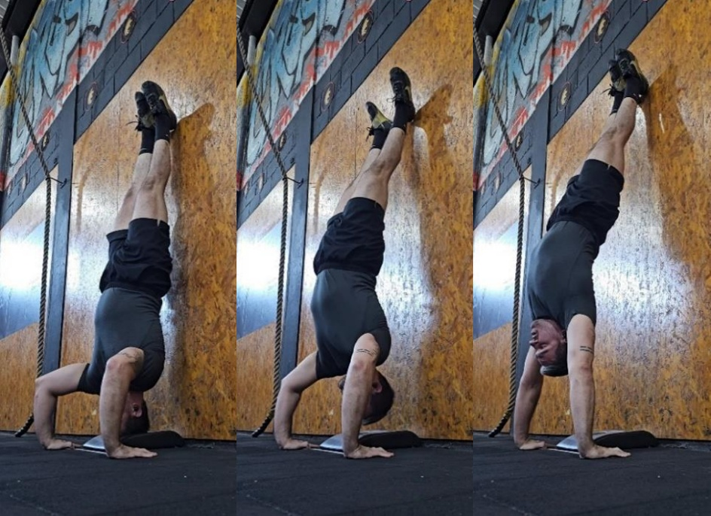
Fig. 3 Standardization and sequence of one repetition of the strict handstand push-up (SHSPU) movement. The sequence illustrates the standardized start position in headstand, followed by elbow extension to full lockout
A repetition was considered valid only if it began and ended with controlled head contact on the AbMat, without the use of any assistance such as momentum generated by hip or knee flexion-extension. Movements involving head bouncing or rapid transitions without stabilization in the headstand were also excluded. Each participant was allowed two attempts, separated by a three-minute rest interval. The highest number of valid repetitions was recorded for analysis.

One-Repetition Maximum (1-RM) Shoulder Press Test
The 1-repetition maximum (1-RM) test for the shoulder press (SP) followed a protocol adapted from Dias et al. [5], commonly used in CrossFit® settings to determine an individual's personal record (PR) for a given day. Participants began with a general warm-up consisting of 10 repetitions using an unloaded barbell (20 kg for males; 10 or 15 kg for females). For the first test set, the load was set at 50% of the estimated 1-RM when known, or at 40% of body mass when no prior value was available. Load was then progressively increased in 10% increments across subsequent sets (i.e., 60%, 70%, 80%, 90%, and 100% of the estimated 1-RM), with a single repetition attempted at each stage to minimize fatigue. A 3-minute rest interval was provided between sets.
If the participant failed to complete a repetition at a given stage, they were allowed a second attempt following a 3-minute rest, with the load reduced by 5%. If successful, they could continue with 5% increases until their true 1-RM was identified. Conversely, if a participant successfully lifted the estimated 100% load and felt capable, they were allowed to attempt higher loads in 5% increments until reaching failure. The highest successfully lifted load with correct technique was recorded as the 1-RM.
To standardize the SP movement, participants received the following instructions: feet hip-width apart, active gluteal and core contraction, and elbows positioned slightly anterior to the bar. To ensure a linear and vertical bar path, participants performed a slight cervical extension to clear the head from the bar's vertical trajectory from the shoulders. Upon reaching full elbow extension (lockout), participants moved the head forward to a neutral position while performing an external shoulder rotation to enhance overhead stability. At the top, participants were instructed to fully extend the elbows, perform external shoulder rotation, and bring the head forward into a neutral position [Figure 4]. Any form of assistance—such as knee or hip drive (i.e., push press), heel elevation, lumbar hyperextension, or bouncing the bar—was strictly prohibited.
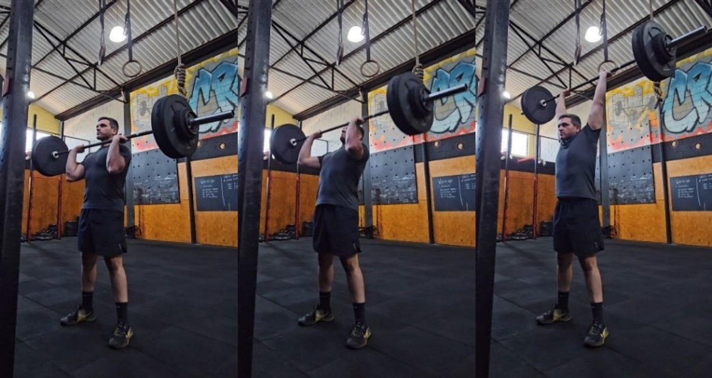
Fig. 4 Standardization and sequence of one repetition of the shoulder press (SP) movement. The sequence depicts the initial position with the barbell at shoulder level and the execution through full elbow extension

Statistical Analyses
A multiple linear regression analysis was performed to examine the predictors of SHSPU performance. The maximum number of SHSPU repetitions was defined as the dependent (response) variable, while relative SP strength (calculated as 1-RM divided by body mass) and years of CrossFit® training were entered as independent (predictor) variables. Regression assumptions were evaluated by visual inspection of the scatterplot and residual diagnostics. Linearity was assessed from the scatterplot, normality of residuals from the normal P-P plot, and homoscedasticity from the plot of standardized residuals versus standardized predicted values. Independence of residuals was assessed using the Durbin-Watson statistic. Residual diagnostics suggested a slight deviation from homoscedasticity, but no major violation was considered sufficient to invalidate the model. All statistical analyses were conducted using SPSS (Version 20.0, IBM Corp., USA).

RESULTS
A total of 108 athletes (66 males, 42 females) completed the study protocol. The descriptive characteristics of the participants, including anthropometric data, training experience, and performance in the SP and SHSPU, are summarized in Table 1. Training experience was treated as an ordinal variable ranging from 1 [3–6 months] to 7 [≥ 5 years].
Table 1. Descriptive characteristics and performance variables of the participants (N=108).

Variables | Male (n=66) | Female (n=42) | Total (N=108)
Age (years) | 31.8 ± 7.4 | 33.0 ± 7.2 | 32.3 ± 7.4
Body Mass (kg) | 80.7 ± 10.5 | 68.3 ± 11.7 | 75.9 ± 12.2
Relative SP Strength (%BM) | 74.0 ± 13.6 | 51.5 ± 8.1 | 65.2 ± 16.1
SHSPU Repetitions (n) | 7.8 ± 6.6 | 1.2 ± 2.6 | 5.3 ± 6.3
CrossFit® Experience, n (%) | ‍ | ‍ | ‍
3–6 months | 7 (10.61%) | 2 (4.76%) | 9 (8.33%)
6 months–1 year | 4 (6.06%) | 9 (21.43%) | 13 (12.4%)
1 - 2 years | 19 (28.79%) | 12 (28.57%) | 31 (28.7%)
2 - 3 years | 15 (22.73%) | 2 (4.76%) | 17 (15.74%)
3 - 4 years | 9 (13.64%) | 8 (19.05%) | 17 (15.74%)
4 - 5 years | 6 (9.09%) | 4 (9.52%) | 10 (9.26%)
≥ 5 years | 6 (9.09%) | 5 (11.90%) | 11 (10.19%)

Note: SP = shoulder press; SHSPU = strict handstand push-up; BM = body mass. All values are expressed as mean ± standard deviation or as absolute frequency and percentage (%).
Relative strength in the SP was a significant predictor of SHSPU performance, as indicated by the regression equation y = –15.2 + 0.314x (β = 0.314, t = 13.896, p < 0.001). The model explained 64.6% of the variance in the number of SHSPU repetitions (R² = 0.646, F = 193.111; p < 0.001), based on the load lifted in the SP relative to body mass (Figure 5). According to the predictive equation, a relative strength of approximately 51.8% in the SP represents the minimum threshold required to perform a single SHSPU repetition.
Fig. 5 Relationship between the number of maximum strict handstand push-ups (SHSPU) repetitions and shoulder press (SP) one-repetition maximum relative to body mass (%SP)
Furthermore, for every 3.2% increase in SP relative strength, the number of SHSPU repetitions is expected to increase by one. Experience in CrossFit® training was not a significant predictor of SHSPU performance (β = -0.062, t = -1.026, p = 0.307).

DISCUSSION
The primary aim of this study was to investigate whether SP strength relative to body mass could significantly predict performance in SHSPU. To the best of our knowledge, this is the first study to examine this relationship, providing practical insights for training prescription. The results confirmed that relative strength in the SP was a significant predictor of SHSPU repetitions. The linear regression model indicated that a relative strength of approximately 51.8% is required to perform one SHSPU repetition, and that each 3.2% increase in SP relative strength is associated with one additional repetition. The robustness of this finding is underpinned by the study’s substantial sample size (N = 108), which provides considerable statistical power and enhances the reliability of the established predictive model compared to smaller-scale pilot studies common in gymnastics research.
These findings align with previous studies comparing exercises using external load and bodyweight. Similar electromyographic activity was found when comparing machine-based leg press to bodyweight exercises such as the chair rise and hip thrust, supporting the concept that strength adaptations can translate across loading modalities [21]. Similarly, an equation was proposed to estimate bench press strength based on push-up performance [17]. In line with these findings, SP relative strength may serve as a practical tool for monitoring progress and prescribing training for SHSPU skill development.
However, SP relative strength explained 64.6% of the variance in SHSPU performance. Nevertheless, the 35.4% unexplained variance is substantial in athletic tasks, likely accounting for technical proficiency, handstand stability metrics, and neuromuscular coordination. A primary biomechanical factor is likely trunk stiffness. In a closed kinetic chain movement such as the SHSPU, maintaining a rigid “hollow body” position is essential to ensure efficient force transmission and prevent energy dissipation through compensatory lumbar hyperextension [13, 18]. Unlike the open kinetic chain in the SP, the SHSPU requires distinct motor unit recruitment and complex scapular stabilization to lift the body's mass against a fixed base [1]. Furthermore, the inverted position introduces unique psychological and physiological challenges. Even with wall support, “inversion anxiety” or the discomfort associated with increased intracranial pressure may trigger protective neuromuscular inhibition, potentially hindering the athlete's ability to express their full-strength potential during the press [7].
Beyond performance prediction, the %SP value may offer useful insights for safety and readiness assessment. According to the regression model, individuals with SP relative strength below the estimated threshold of 51.8% are unlikely to complete a single SHSPU repetition. This threshold could serve as an objective indicator of physical preparedness for practicing handstand-based skills, potentially offering a more reliable alternative to subjective assessments or bodyweight-only progressions. Knowing this value may also help reduce injury risk during early exposure to skills such as handstand walk or static handstand holds, where weight is supported through the upper limbs [9, 20, 22].
Interestingly, experience in CrossFit® training was not a significant predictor of SHSPU performance. These results are consistent with a high rate of inability to perform strict gymnastic movements among CrossFit® practitioners [14]. Most performance-focused CrossFit® research emphasizes metabolic parameters and Olympic weightlifting skills, with limited attention to gymnastic components such as the SHSPU [15]. This underscores a gap in the literature and the need for specific assessment tools and training strategies for gymnastic skill acquisition in functional fitness programs.
This study represents a pioneering effort in quantifying the relationship between maximal pressing strength and vertical bodyweight gymnastics in a CrossFit® context. Despite the ubiquity of the SHSPU in functional fitness programs, scientific literature has predominantly focused on descriptive technique or injury prevalence, leaving a gap in the understanding of the strength prerequisites for the movement. To the best of our knowledge, this is the first study to establish a clear predictive model using the 1RM SP as a benchmark for SHSPU performance. The pressing capacity and scapular stability developed through this movement are likely essential for high-skill tasks such as handstand walking, freestanding handstand push-ups, and the overhead stability required for heavy snatches and jerks [6, 7]. This study bridges a gap between traditional resistance training metrics and specialized gymnastics performance in the sport.

Practical Implications
As CrossFit® programming evolves, gymnastic skills, particularly handstand variations, are increasingly demanded. However, progression in these skills often lacks objective performance criteria. This study provides a practical metric by identifying relative strength in the SP as a predictor of SHSPU performance. Coaches can use the threshold of 51.8% of body mass in the SP as a benchmark for assessing readiness to attempt SHSPU. Athletes below this value may benefit from focused overhead pressing work before progressing to inversion-based skills. Using SP as a monitoring tool can also help structure training safely and identify whether limitations are strength-related or technical, supporting more individualized programming and reducing injury risk during gymnastic skill acquisition.

Study Limitations
Methodological limitations should be considered when interpreting these results. The cross-sectional design does not permit causal inference. Although a full five-minute rest was provided between tests, performing both assessments in the same session may have introduced residual fatigue effects. The fixed 81 cm hand placement used for both SP and SHSPU may have resulted in subtle discrepancies in joint positioning between the movements. Additionally, CrossFit® training experience was collected in ranges of years via questionnaire rather than as a continuous variable, limiting the accuracy of the analysis. Finally, factors such as anthropometrics, body composition, and the use of ergogenic aids were not controlled and may have influenced the outcomes. Future studies should explore specific neuromuscular adaptations, force output comparisons, and individualized programming approaches to enhance transferability between SP and SHSPU in both novice and advanced athletes.

CONCLUSION
In conclusion, this study demonstrates that relative maximal shoulder press strength is a powerful and significant predictor of strict handstand push-up performance in CrossFit® practitioners, explaining nearly two-thirds of the total variance. A baseline threshold of approximately 51.8% of body mass in the shoulder press is established as a critical prerequisite to executing a single strict repetition. Conversely, general training volume measured in years of experience does not guarantee performance proficiency. These findings provide coaches and practitioners with an objective, evidence-based physical benchmark to optimize progression, personalize training prescription, and mitigate injury risks during upper-body vertical pressing transitions.

REFERENCES
- Augustsson J, Thomeé R. Ability of closed and open kinetic chain tests of muscular strength to assess functional performance. Scand J Med Sci Sports. 2000;10:164–8.
- CrossFit LLC. Affiliate. 2022. https://www.crossfit.com/affiliate. Accessed 17 Jun 2026.
- CrossFit LLC. The shoulder press. 2022. https://www.crossfit.com/essentials/the-shoulder-press. Accessed 17 Jun 2026.
- CrossFit LLC. The Strict Handstand Push-Up. 2022. https://www.crossfit.com/essentials/the-strict-handstand-push-up. Accessed 17 Jun 2026.
- Dias RMR, Cyrino ES, Salvador EP, et al. Influência do processo de familiarização para avaliação da força muscular em testes de 1-RM. Rev Bras Med Esporte. 2005;11.
- Feito Y, Heinrich KM, Butcher SJ, Carlos Poston WS. High-intensity functional training (HIFT): Definition and research implications for improved fitness. Sports. 2018;6.
- Firmansyah H, Martini T, Darajat J, Mudjihartono M, Hendrianto R. Gymnastics Performance Analysis: The Role of Anxiety and Concentration in Gymnasts’ Success. J Pendidik Jasmani Olahraga. 2024;9:126–32.
- Glassman G. Level 1 training guide. The CrossFit Journal. 2020.
- Hector R, Jensen JL. Sirsasana (headstand) technique alters head/neck loading: Considerations for safety. J Bodyw Mov Ther. 2015;19.
- Heidel KA, Novak ZJ, Dankel SJ. Machines and free weight exercises: a systematic review and meta-analysis comparing changes in muscle size, strength, and power. J Sports Med Phys Fitness. 2022;62. https://www.minervamedica.it/index2.php?show=R40Y2022N08A1061
- Johnson A, Meador M, Bodamer M, Langford E, Snarr RL. Exercise technique: Handstand push-up. Strength Cond J. 2019;41.
- Kholinne E, Zulkarnain RF, Sun YC, et al. The different role of each head of the triceps brachii muscle in elbow extension. Acta Orthop Traumatol Turc. 2018;52:201–5.
- Kibler WB, Press J, Sciascia A. The role of core stability in athletic function. Sports Med. 2006;36:189–98.
- Kilipper R, Okuyama AR, Joaquim VHA, et al. Prevalence of gymnastics-based movement ability/inability among high-intensity functional training practitioners. Trends Sport Sci. 2023;30.
- Meier N, Schlie J, Schmidt A. CrossFit®: ‘Unknowable’ or Predictable?—A Systematic Review on Predictors of CrossFit® Performance. Sports. 2023;11.
- Rassier DE, MacIntosh BR, Herzog W. Length dependence of active force production in skeletal muscle. J Appl Physiol. 1999;86.
- Saeterbakken AM, Van Den Tillaar R, Fimland MS. A comparison of muscle activity and 1-RM strength of three chest-press exercises with different stability requirements. J Sports Sci. 2011;29:533–8.
- Sands WA, Caine DJ, Borms J. Scientific Aspects of Women’s Gymnastics. Basel: S. Karger AG; 2002. https://doi.org/10.1159/isbn.978-3-318-00894-4
- Soriano MA, Suchomel TJ, Comfort P. Weightlifting Overhead Pressing Derivatives: A Review of the Literature. Sports Med. 2019;49:867–85.
- Summitt RJ, Cotton RA, Kays AC, Slaven EJ. Shoulder Injuries in Individuals Who Participate in CrossFit Training. Sports Health. 2016;8.
- Vinstrup J, Calatayud J, Jakobsen MD, et al. Electromyographic comparison of conventional machine strength training versus bodyweight exercises in patients with chronic stroke. Top Stroke Rehabil. 2017;24.
- Weisenthal BM, Beck CA, Maloney MD, DeHaven KE, Giordano BD. Injury rate and patterns among crossfit athletes. Orthop J Sports Med. 2014;2.

STATEMENTS AND DECLARATIONS
Funding This work was supported by the Coordenação de Aperfeiçoamento de Pessoal de Nível Superior - Brasil (CAPES) - Finance Code 001.
Competing Interests The authors have no relevant financial or non-financial interests to disclose.
Author Contributions All authors contributed to the study conception and design. Data collection was performed by GPL. Data analysis was performed by MMG. The first draft of the manuscript was written by GPL, and LFS, LL, and MN contributed to the critical review of the intellectual content. MMG supervised the final version of the work. All authors read and commented on previous versions of the manuscript, and approved the final version.
Ethics Approval This study was performed in line with the principles of the Declaration of Helsinki. Approval was granted by the Ethics Committee of the School of Physical Education and Sport of Ribeirão Preto, University of São Paulo (Date: June 26, 2024 / No. 6.912.838; CAAE: 79816724.4.0000.5659).
Consent to Participate Informed consent was obtained from all individual participants included in the study.
Consent to Publish The authors affirm that human research participants provided informed consent for publication of the images in Figures 3 and 4.

